Lab 7: Renewable Energy

EG-UY 1003 Y1B

Jason Yao

Team members: Sam Krickellas, Timur Nagishpayeu

Date of experiment: 27th July 2015

Date due: 29th July 2015

**Abstract**

The objective of this lab was to design and build a motorized vehicle that was powered by renewable energy sources. A secondary objective was to win the competition between the EG1003 teams entered in the race by achieving the highest Competition Ratio. The car was successfully built and ran utilizing wind-powered energy, and achieved third place in the EG1003 competition. This lab was significant because it demonstrated that renewable energy sources could be used effectively to power motorized vehicles.

**Introduction**

As this lab was a competition between EG 1003 teams, the winning team was determined by the highest Competition Ratio, shown in Fig. 1.

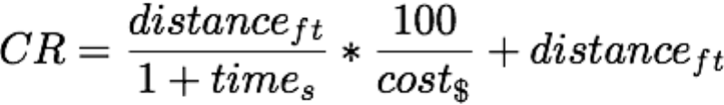

Fig. : Competition Ratio

In this ratio, distanceft was the distance traveled by the car in feet, times was the time it took to reach the point of stopping in seconds, and cost$ was the cost of materials used to build the vehicle in US dollars.

As distance was a large factor in the CR, it was decided the car should maximize the distance traveled, which would make up for a slightly higher cost. Since the maximum distance was dependent on how long the motors were in motion, which was directly proportional to the amount of energy stored on the vehicle, it was decided to maximize the energy storage in the form of using as many capacitors as was allowed.

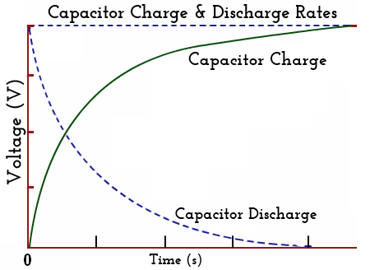 A **capacitor** is defined by the EG 1003 Lab Manual (2015) as an “electrical device used to store charge temporarily”. Some capacitors can thus be used in the place of batteries, though its charging and discharging is logarithmic, as shown in Fig. 2, which results in a disadvantage when used as power storage sources compared to fuel cells.

Fig. : Capacitor charge & discharge voltage over time

As Fig. 2 shows, when a capacitor is being discharged, more electricity is outputted initially than at the end, which results in the motors in the car to move more quickly at the start, before gradually slowing down.

Another form of energy storage is a **fuel cell**. These cells store chemical energy that can then be converted into electrical energy, and can be fueled by fluids such as hydrogen, methane, or even gasoline. A fuel cell is constructed from an anode chamber, a cathode chamber, an electrolyte, and two bipolar plates, as shown in Fig. 3. This allows the fuel cell to store energy in the form of chemical energy, due to the hydrogen and oxygen gasses obtained from the electrolysis process.

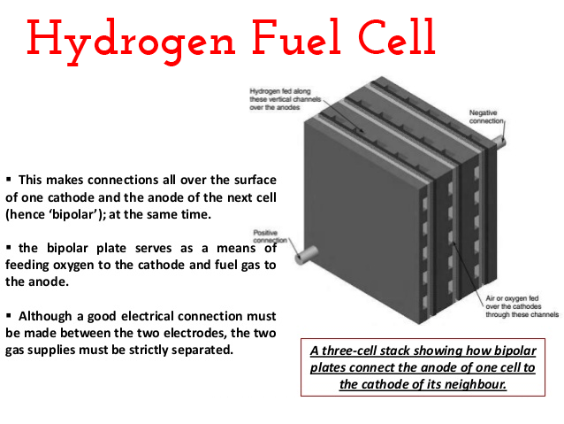

Fig. : Hydrogen fuel cell

The energy stored in a fuel cell can be used to power anything from cities to vehicles. The biggest disadvantage of fuel cells however are its size, since in order to generate large amounts of electricity, a large amount of gas has to be generated and stored, rendering current fuel cells to generally be very large.

The energy that can be stored in capacitors or fuel cells can come from any source of energy that can be processed into electrical energy, with two majour categories – **renewable** and **non-renewable** energy. As the name implies, renewable energy is defined as energy that comes from sources that are naturally replenished in a relatively short timeframe. Non-renewable energy sources cannot naturally replenish in this time frame (e.g. coal or gasoline).

A few examples of renewable energy sources include **solar** and **wind**. For solar energy sources, sunlight warms a solar panel, which captures free electrons from the sunlight and creates a voltage between two plates, thus generating electricity with certain materials such as silicon or copper indium gallium de(selinide) (CIGS). An advantage of solar power is the consistency from day to day, as the panels can be placed in the sun and generate electricity for as long as there is sunlight. A disadvantage of solar energy is the amount of time needed to generate electricity, as the conversion from sunlight to electricity is much longer than wind energy.

Wind energy sources on the other hand transforms mechanical energy from a moving wind turbine into electrical energy. These turbines utilize the motion from the wind blades to turn a series of shafts connected to a gearbox, which eventually turns an electric generator, which generates electricity. An advantage in using wind power is the sheer amount of electricity that can be generated, far outstripping solar energy generation when in a high wind. A disadvantage for wind is when there is no wind to blow against the wind blades, thus making wind turbine energy generation more inconsistent than solar energy generation over time.

For the design of the vehicle, it was decided that the hydrogen fuel cell was too large and heavy for the vehicle, so capacitors were used instead. For the energy source, when solar energy generation was compared to wind energy generation, the wind turbine produced more than three times the voltage of the solar panel. Thus the design utilized a wind turbine for renewable energy generation, and capacitors for energy storage.

A key factor in maximizing the CR was the axiom of **minimal design**. This meant that the car had to be built efficiently, using as many of the purchased parts as possible. In this case, the car utilized nearly all the materials purchased, with only a foot of tape left over. Thus, the car was minimally designed, with only crucial parts such as wheels, a motor and framing parts used in order to construct the car.

**Procedures**

A LEGO motor, 4 1-Farad capacitors, 3 alligator clips, 4 LEGO medium wheels and miscellaneous framing parts were used to construct the vehicle. A wind turbine was used to generate the electrical energy that was stored in the capacitors of the vehicle.

First, each energy source/storage option was tested in order to determine the advantages and disadvantages of each option. The first energy source to be tested was the solar panel, in which the panel was linked to a motor with alligator clips, and measured with a multi-meter to determine the output voltage and current.

The next energy source to be tested was wind power, in which a motor was linked to a wind turbine with alligator clips, and measured with a multi-meter to determine the output voltage and current. After the data was gathered, the turbine was disconnected from the motor.

After the energy sources were evaluated, energy storage options needed to be tested to determine the advantages and disadvantages of each one. The first energy storage option to be tested was the capacitors, in which a capacitor was wired to a 3V battery. The capacitor was fully charged when the current reached 0, and the battery was then disconnected. The capacitor was then wired to a motor along with a multi-meter to measure the amount of current in the circuit. After the current and voltage was gathered, the motor and capacitor was disconnected.

The second energy storage to be tested was the hydrogen fuel cell, in which a hydrogen cell was placed in water, and then wired to a battery to begin the electrolysis process. After a sufficient amount of time, the cell was connected to a motor, along with a multi-meter to gather current and voltage information. After the data was gathered, the cell was disconnected from the motor.

After determining that wind power and capacitors were the optimal energy source/storage combination, the vehicle was then constructed, with a single motor powering the minimally designed car, as shown in Fig. 4. In order to keep the wires from being run over, tape was used to secure the wires.

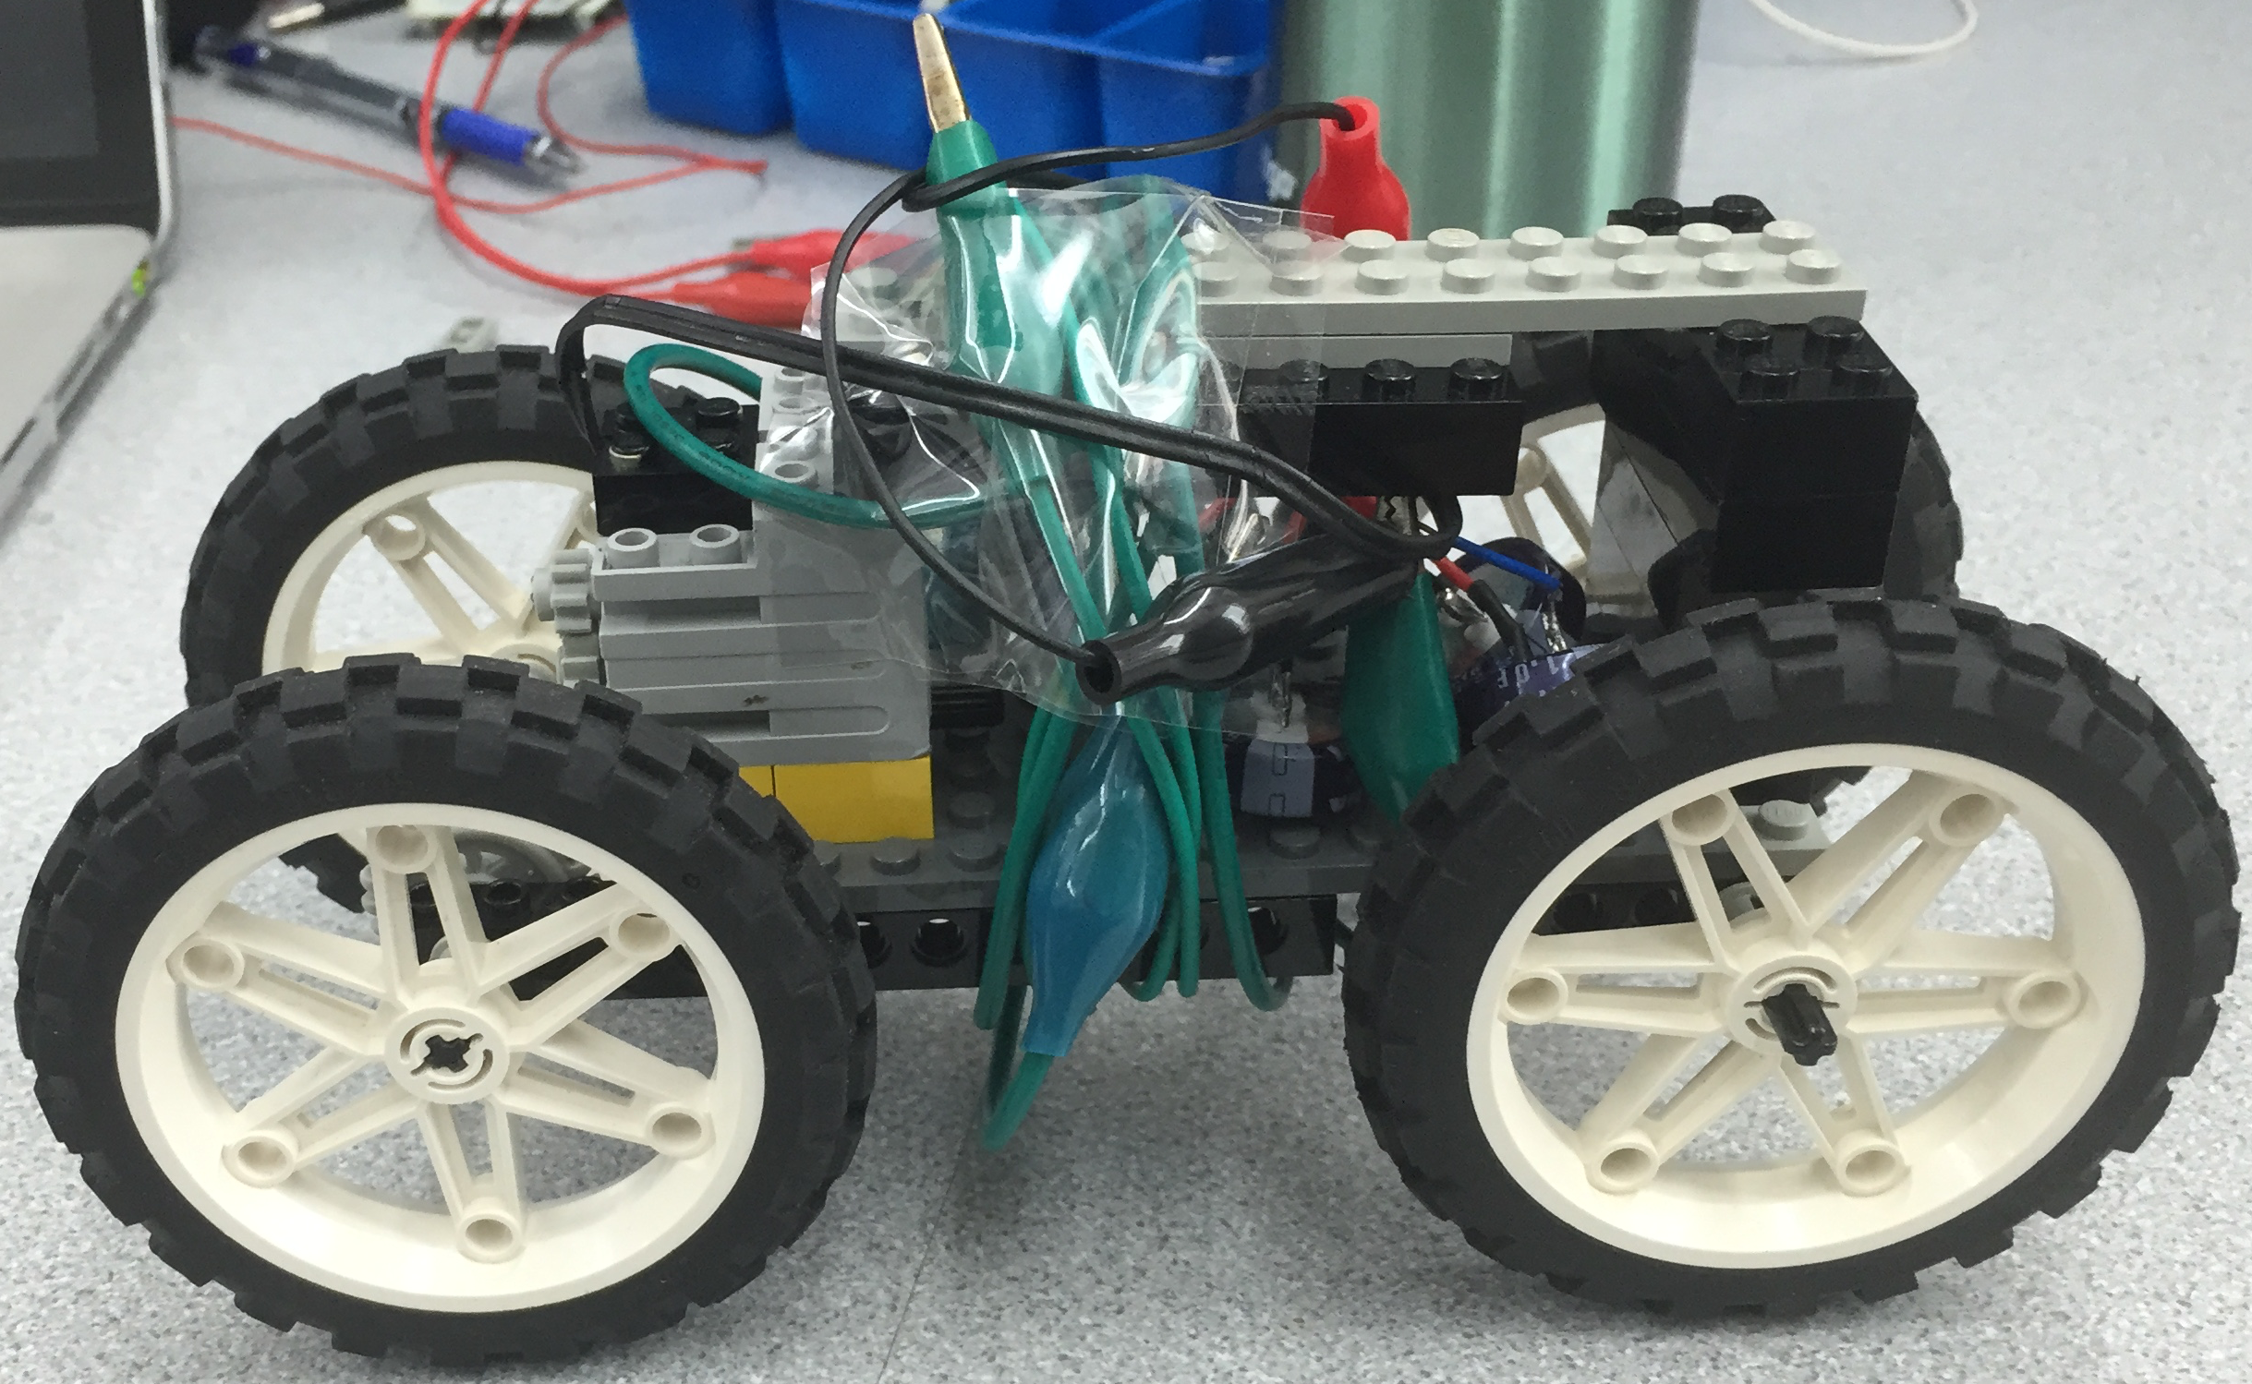

In order to maximize the capitance (amount of energy stored), the capacitors were wired up in parallel, as shown in Fig. 5.

Fig. : Final vehicle design

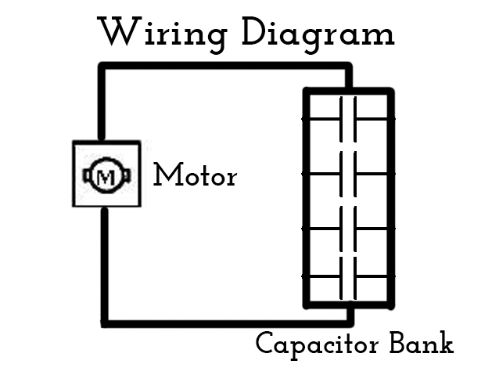

Fig. : Wiring diagram

**Data/Observations**

When testing the solar panel’s voltage generation, it was found to be more then three times less effective than wind power, as the solar panel generated 0.009062 watts compared to the wind turbine’s generated power of 0.03 watts. When testing hydrogen fuel cells as an energy storage medium, it was determined that simply from its weight and size alone that building a fuel-cell storage using car would be unfeasible, and so the capacitors were chosen to be used instead.

In order to maximize capitance, the capacitors had to be wired in parallel, as wiring them in series would result in much lower capitance.

One thing to note when the car began its trial run was that it had a loose gear that then proceeded to come loose when the car was in motion – this caused the car to stop in place even though the motor was still moving, causing a lower CR.

The car finished third in the race, due to the loose gear, which was lower than expected due to the designed cost efficiency and optimized power storage.

The cost breakdown shows a middling cost compared to other EG 1003 teams, as shown in Fig. 6.

|  |  |  |  |
| --- | --- | --- | --- |
| **Material** | **Cost per unit** | **# of units** | **Subtotal** |
| Horizon wind turbine | $5.00 | 1 | $5.00 |
| 1 Farad 2.5V capacitor | $3.00 | 4 | $12.00 |
| 1 Alligator clip | $0.50 | 3 | $1.50 |
| Tape (1 foot) | $0.10 | 2 | $0.20 |
|  |  |  |  |
|  |  | **Total** | $18.70 |

Fig. : Cost breakdown

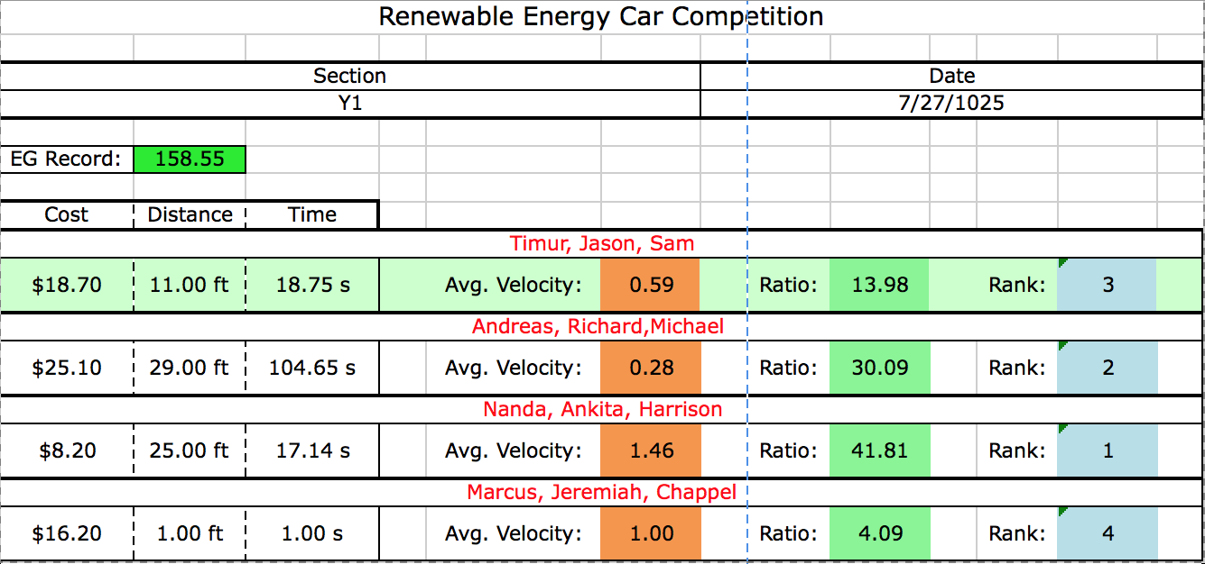From the above data, the CR was calculated to be 13.98, as described in the EG1003 competition results in Fig. 7.

Fig. : EG1003 competition results

**Discussion/Conclusions**

Overall, the car came in third place in the EG1003 competition, primarily because of the loose gear that cause the vehicle to stall. The car could thus be improved by securing the gear train so that when in use it will not slip.

The design of the car succeeded in that there was a lot of energy available to the minimally built car, and did less than expected due to mechanical failure, not design failure. Besides securing the gear train to improve the design, linear distance could have also been maximized by changing the centre of gravity to be more forward, by having larger wheels in the back, and smaller wheels in the front.

To improve the CR of the car, costs can be minimized, possibly in the form of fewer capacitors, since the maximizing of the number of capacitors allowed raised the cost of the vehicle by a large margin.

As shown in Fig. 7, the winning team had a high CR due to having nearly half the cost of the average car, even though it came second in terms of overall linear distance traveled. This shows the importance of cost management when designing a vehicle, as it is simply not enough to try and maximize the potential power.

**Works Cited**

NYU Polytechnic School of Engineering. 2015. “Lab 7: Renewable Energy”. EG 1003 Online Lab Manual. Accessed 27 July 2015 from manual.eg.poly.edu.

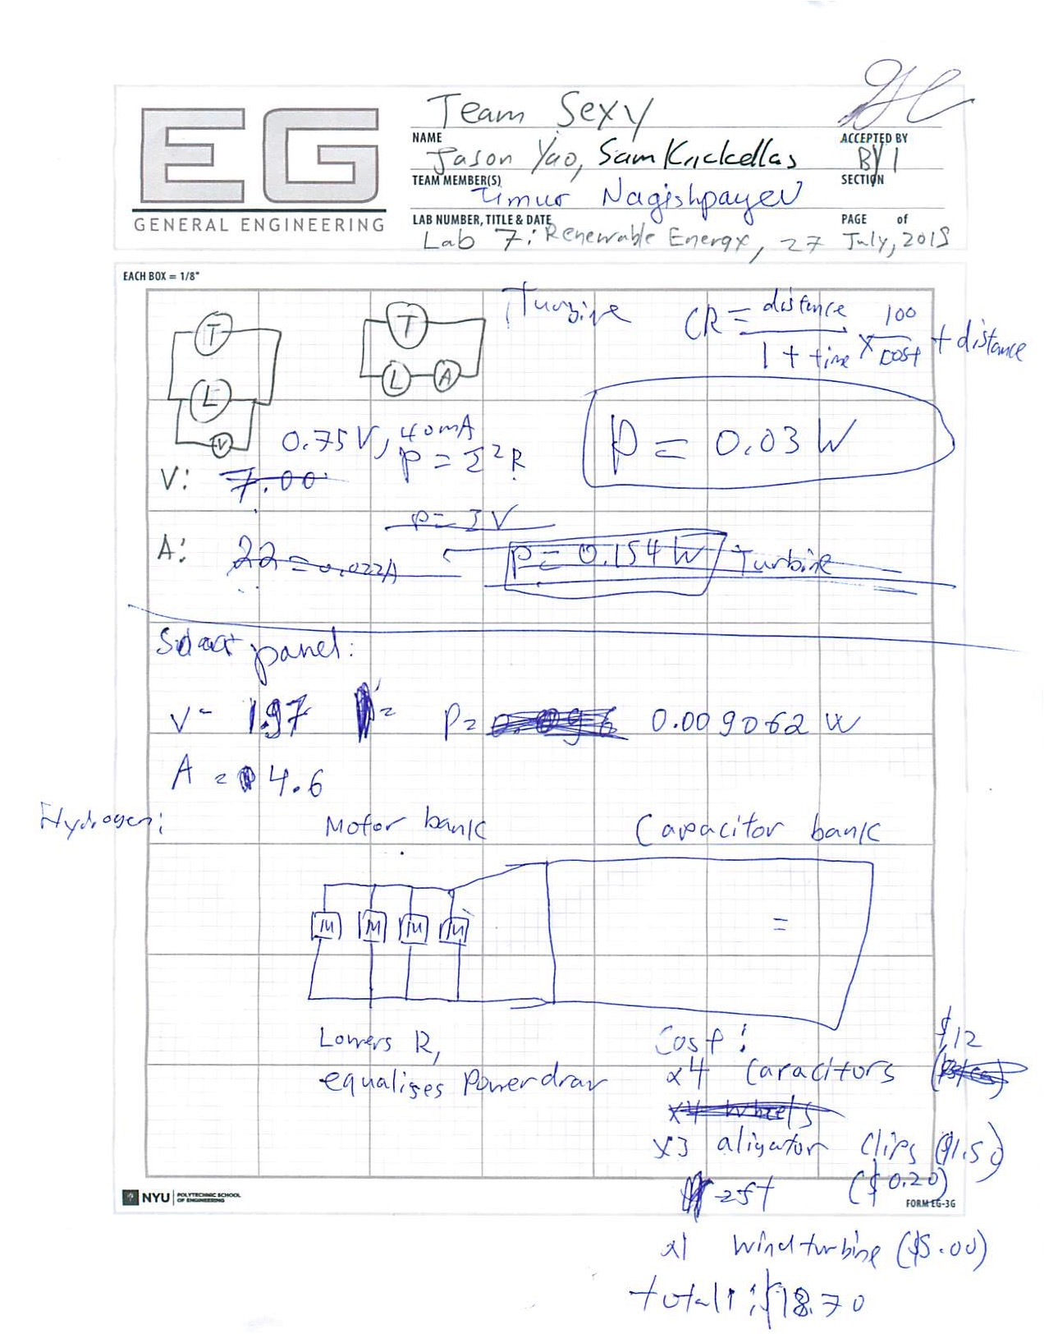

Fig. 8: Initial design sketch